

Providing a strong foundation for life

Contractor Code of Conduct


Purpose

  - The purpose of this document is to set out the minimum standards required from all contractors, subcontractors, consultants and their agents (‘Contractor’) employed by
Karbon Homes Limited (‘Karbon’) in the delivery of works and services in an occupied or unoccupied property, or anywhere on an estate or scheme.
For the avoidance of doubt, Contractors must ensure that any subcontractors employed by them adhere to the guidelines set out in this code of conduct.

General requirements

  - Any Contractor employed by Karbon must comply with the Contractor Code of Conduct (the ‘Code’) at all times.

  - Karbon reserves the right to obtain feedback and information from its residents and employees on the standard of work, behaviour and probity of Contractors.

  - If a Contractor commits a serious breach of this Code, the Contractors actions may amount to a default under the Contract and could result in termination of the contract at no cost to Karbon.

  - When delivering works on behalf of Karbon, at all times Contractors must:
    - Behave:
- In a proper and professional manner.
- With courtesy to any Karbon resident, employee or agent.
- With sensitivity toward residents, including vulnerable residents. Karbon recognises that someone can be vulnerable for a number of reasons, these may include:
  - People with a physical or sensory disability, people with a learning disability, people with mental health issues, people who are seriously ill, people experiencing domestic abuse, older people, single parent families, pregnant women (especially teenagers), unemployed people, former members of the armed forces, people leaving care, ex-offenders, people who are considered to be financially excluded, people with substance abuse problems, people who have difficulties understanding, speaking or reading English.
    - Carry photographic ID and present it when requested to any Karbon resident, employee or agent upon request. ID should be visible and worn at all times.
    - Be dressed appropriately, and where required, wear Personal Protective Equipment (PPE).

    - Take particular note of any information sent to them regarding Karbon residents and treat such material in accordance with the General Data Protection Regulations 2018 (ensure that any personal information they use or third parties they choose to instruct is managed in accordance with the Data Sharing Agreement).
    - Respect employer confidentiality in any discussions with Karbon residents.
    - Refrain from commenting on works carried out by third parties.
    - Report any instances where they have been verbally or physically abused or events which have led to them leaving a site to Karbon within two hours.

  - Contractors must treat all Karbon residents, employees and agents politely, positively and with consideration in accordance with the protected characteristics highlighted in the Equality Act 2010.

  - Contractors must respect the diverse nature and needs of Karbon residents.

  - Contractors must respect religious or similar customs and immediately advise Karbon if such matters raise a potential conflict, e.g. the need to remove safety footwear indoors.

  - Contractors must take all appropriate additional care when a Karbon resident, employee or agent has any health, sensory or mobility impairments.

  - Contractors must advise Karbon Homes immediately if a potential language barrier exists and if the assistance of an interpreter is required.

Health and safety

  - The Health and Safety at Work Act 1974, places a duty upon Karbon to ensure that all property it controls are safe. All Contractors must comply with the requirements under the Act and are under the terms of the contract.


  - Before commencing work, the Contractor must ensure they are aware of and comply with all legislation relevant to the work to be carried out and agree throughout the duration of
the contract to comply with them.

  - The Contractor must adhere to any special conditions as set out in any specific contract documents.

  - The Contractor must make themselves aware of any relevant guidance notes published by the Health and
Safety Executive.

  - The contractor will ensure that:
    - They only carry out work in which they are qualified to complete.
    - They only carry out work in which they are competent.

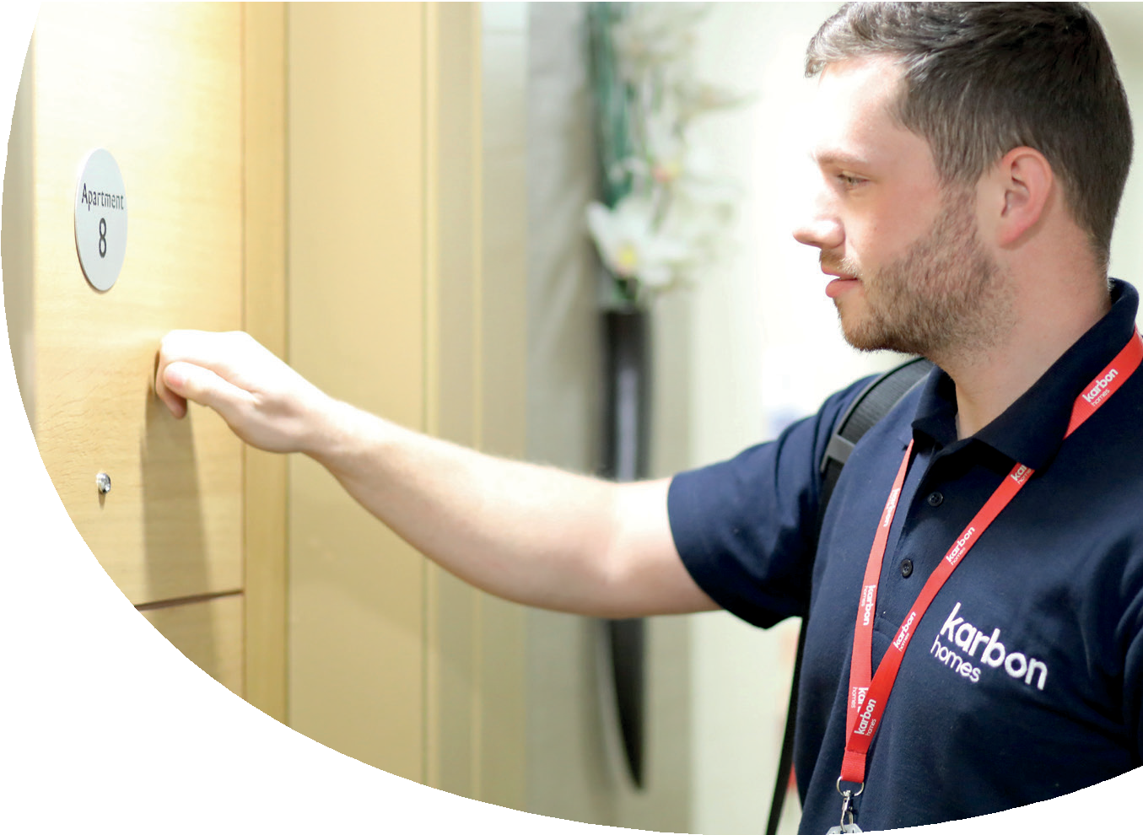
    - If they have over five employees, have a clearly defined Health and Safety Policy and that all employees and agents are aware of its content.
    - All works are completed to satisfactory and safe systems.
    - They are fully aware of any emergency evacuation procedures and the assembly points that may be in force in any given site.
    - The sharing or provision of sanitary, welfare, canteen and first aid facilities, has been agreed with the parties concerned.
    - Any necessary licenses, permits or consents in connection with the work have been obtained.
    - A structural engineer has been consulted where required.
    - The position of all public utilities which might endanger health and safety have been identified and any necessary precautions taken.
    - Where applicable, all pre-construction information has been read and understood with all and any further investigations necessary complete prior to commencing work.
    - All potential hazards are identified with necessary steps taken to remove reduce or avoid the hazard.
    - Prepare all method statements and risk assessments required prior to undertaking any works.
    - Where applicable have in place a Health and Safety Construction Phase Plan prior to commencing works, and where necessary ensure the plan is updated.
    - Where applicable, attend the Principal Contractors Health and Safety induction, prior to commencing work on site.

Working in Karbon Residents’ Homes


  - Where instructed by Karbon, the Contractor will contact residents using the contact information provided by Karbon to arrange a convenient time to carry out any inspections or works, giving Karbon residents at least 24 hours’ notice unless agreed otherwise. All correspondence by the Contractor will clearly outline that they are working on behalf of Karbon. If a contractor is asked by the Residents not to use a particular contact method they should advise
Karbon of this within one working day.

  - Where arrangements for access cannot be made by telephone or letter, the Contractor must visit the Karbon resident to agree a mutually convenient appointment to carry out the work. As discussed
in the paragraph above, Karbon residents must be given at least 24 hours’ notice. If the Karbon resident is not at home a card or similar must be left within the property requesting the Karbon resident to contact the Contractor directly to agree a convenient appointment.


  - In the event of a missed appointment, or the Karbon resident refusing the Contractor access to the property, the Contractor must notify Karbon Homes within one working day (in writing) and await further instruction.

  - When arriving for a scheduled appointment, the Contractor must introduce themselves to the Karbon resident, show proof of
their identity and clearly explain the works to be carried out, referencing previous correspondence if necessary. The Contractor will answer any questions the Karbon resident may have in conjunction with the requirements of the Code.

  - Prior to commencement, the Contractor must explain the scope of works to the Karbon resident. If the scope of
works does not meet with the Karbon resident expectation, the Contractor must advise Karbon immediately and seek
further guidance (the contractor must not get into any discussions relating to expectations).

  - The Contractor will not carry out any works in Karbon residents’ homes
if an adult (over 18 years of age) is not present. In such circumstances the Contractor will leave the property immediately and notify Karbon Homes and await further instruction.

  - The Contractor will generally be permitted to work only between the hours of
8.00 a.m. and 5.00 p.m., Monday to Friday (excluding Public Bank Holidays), except in cases of emergency or where Karbon Homes have given their specific permission to work at other times. In such circumstances the specific agreement (preferably in writing) of the Karbon resident(s) affected by the work will also be required.

  - The Contractor may in specific circumstances be required to work during irregular hours. Such arrangements will be made via the relevant contract or purchase order, and will be agreed by both the Karbon resident and Karbon.

  - Where possible the Contractor should ensure external works are carried out when the Karbon resident or a nominated representative is present. If external work is completed in the absence of the Karbon resident or a nominated representative, a card or similar should be left at the property advising the Karbon resident what works have been carried out.

  - Should the contractor leave a property prior to the completion of the works, the Karbon resident must be advised of the reason for non-completion. In addition, the Contractor must advise the date and time of the anticipated return, including the estimated final completion of the works.

  - The Contractor must seek express written approval from Karbon Homes before carrying out any variation requests made by the Karbon resident. The Contractor should note that payment will not be made for extra work carried out which has not been expressly approved by the nominated Karbon officer.

  - Contractors must not:
    - Make comments to Karbon residents about the condition of their accommodation, lifestyle, or the accommodation or lifestyle of other Karbon residents.
    - Play radios or similar either inside or outside properties (unless they get permission from the resident).
    - Smoke in Karbon residents’ homes or gardens.
    - Work under the influence of alcohol or drugs.
    - Use bad language or behave in an offensive way.
    - Eat food within the property boundary without permission.
    - Use any facilities within Karbon residents’ homes without permission. Where permission is obtained any such facilities should be treated with respect.
    - Leave their own valuables e.G. Tools unattended when in the property.
    - Leave documentation unattended and or in sight of Karbon residents.

  - The Contractor is not permitted to hold keys of occupied properties, or complete internal works unaccompanied to occupied, unless specifically agreed with
the resident. We suggest that the Contractor should ask the resident to sign an indemnity form before agreeing to anything.

  - Contractors must protect Karbon residents’ belongings from damage while they are carrying out any works.

  - Contractors must take all necessary reasonable action to ensure the protection of the property worked on, the curtilage, and any adjoining properties. Specifically, operatives will be required to employ the use of dust sheets and protective coverings whenever dust, dirt, paint, mortar or similar material is likely to foul surrounding property or flora.

  - Where practicable, the Contractor will restrict internal works being carried out to one room at a time in order to minimise disruption.

  - The Contractor is responsible for ensuring that, where appropriate, any statutory consents (e.g. scaffolding on a pavement) are obtained before work commences, and that any statutory notices (e.g. building regulation notices) have been applied for.

  - The contractor must ensure that their vehicles are parked in such a way as to not obstruct Karbon residents’ or the general public’s right of way, or cause damage to verges and footpaths.

  - Contractors must ensure the safety of Karbon residents and their households by keeping safe all materials, plant, tools and equipment. If there are children in the property the Contractor must ask Karbon residents to remove their children from the risk area if in the opinion of the Contractor this is necessary. If, in the opinion of the Contractor, the Karbon Resident does not comply with any such requests, or the proposed works cannot be carried out safely, the Contractor will be entitled to stop the works immediately and to contact the nominated Karbon officer for guidance on next steps as a matter of urgency and within one working day.

  - Any requirement for temporary storage of tools, plant and materials within a property boundary will be at the Contractor’s risk and should be agreed with the Karbon resident and Karbon, including proposed location and anticipated duration.

  - The Contractor will treat all Karbon residents’ possessions and furniture with due care and respect. The Contractor will will pay particular care if moving Karbon residents’ furniture and/or possessions which should only be done in discussion with the Karbon resident, once a damage waiver form has been
signed, particularly in cases where there is a disabled person in the household or where there may be cultural or religious items involved. Any damage to Karbon residents’ property must be reported to Karbon within one working day (it is the Contractor’s responsibility to rectify the damage and bear any costs). Furniture etc. must be restored as far as possible to its original place upon completion of the work. We suggest that the Contractor should ask the resident to sign an indemnity form before agreeing to move any furniture/belongings.

  - The Contractor may only use a Karbon resident’s electricity supply, water supply and/or telephone as is necessary to carry out the agreed works.

  - The Contractor must ensure that Karbon residents are given access to essential services (heat, hot water, electricity, gas, etc.) at the end of each day, even if work is not completed, together with sufficient facilities to allow for cooking and food preparation. The property must be left safe for the occupants to use and measures taken to eliminate potential hazards.

  - The Contractor will provide temporary protection and warning signage to the property where necessary during delivery of the works and completion of the works.

  - Karbon residents must be kept informed each day about the work planned to take place the following day and whether any preparatory work such as clearing cupboards etc. should be completed by the Karbon resident.

  - Contractors must leave the property being worked on clean, tidy and free of any debris, rubbish, plant, tools and equipment at the end of each working day and at the completion of the works.

  - On completion of works the Contractor must also:
    - Provide verbal instructions and/or operating demonstration, all relevant full operating manuals and safety certificates to Karbon residents where appropriate e.g. Installation of a new boiler.
    - Test all domestic services on re-connection and/or completion.
    - Agree and sign off completed works with the Karbon resident and the nominated Karbon officer in the case of planned maintenance works.
    - Agree and sign off completed works with the Karbon resident in the case of day-to-day repairs.
    - Agree the scope and nature of and snagging and/or outstanding works with the Karbon resident and the nominated Karbon officer, and agree a reasonable timeframe to complete the outstanding works.

Safeguarding

  - All Karbon staff, Contractors and representatives have responsibility for safeguarding vulnerable adults and children at risk.

  - A vulnerable adult at risk is a person aged 18 or above who is, or may be eligible for community care services and whose independence and wellbeing is at risk due to abuse or neglect.

  - The Karbon safeguarding procedure also covers children and young people under 18 years of age.

  - All Karbon staff, Contractors and representatives are responsible for raising alerts where abuse, neglect and alarming behaviour such as potential drug misuse and behaviour related to CONTEST, for example, may be taking place. Staff and
Contractors have frequent contact with Karbon residents and may see, hear or be told something that suggests abuse, neglect or alarming behaviour. In which case, they must report this to Karbon Homes, or if appropriate, the staff member or Contractor should dial 999 and request the police.

  - If a vulnerable adult or a child confides in a Contractor, time should be taken to listen carefully and to explain that this will be reported to Karbon Homes. If a Contractor sees or hears anything of concern, this should be immediately reported to Karbon Homes.

  - Under no circumstances must Contractors confront or alert residents regarding any allegations. If someone is in immediate danger, the Contractor should dial 999 and request the police.

Reputation, communication and brand management


  - Contractors must request the Karbon Homes logo from Karbon, rather than copying from another source. All logo use and written references to Karbon must be in line with the Karbon Homes brand and tone of voice guidelines, these can be sent on request.

  - Any PR or announcements referencing contractor work for or with Karbon Homes, either via print, digital or social media, must be agreed by the Karbon Communications and Marketing Team
in advance.

  - If contractors are considering submitting award entries for their work with or on behalf of Karbon Homes, this must be agreed by the Karbon Communications and Marketing Team in advance. If appropriate, the team can support contractors with a joint award submission.

  - Any direct communication from contractors to any Karbon Homes’ residents must be agreed with the Karbon Communications and Marketing Team before issuing.

  - Contractors must immediately highlight any potential issues regarding their conduct that may reflect negatively on Karbon Homes’ reputation. Contractors will work with Karbon to agree any mitigation and appropriate communications.

Complaints

  - Contractors must demonstrate they have a formal complaints handling procedure in place, and respond to any complaints they receive from Karbon residents within the timescales detailed in the current Karbon Homes Complaints Policy (copy available upon request), unless otherwise specified within the agreement.

  - Any complaints must be recorded and reported to Karbon Homes within one working day of receipt.

  - If the Contractor encounters a Karbon resident who becomes hostile, aggressive or behaves in a manner which the Contractor believes is threatening, the Contractor must tactfully withdraw and report the incident to Karbon within two working hours.

  - If the Contractor feels unable to undertake specified work within a Karbon property, they must contact Karbon Homes to discuss next steps.

Probity

  - The Contractor must take all appropriate steps to ensure that neither the Contractor, nor any of its representatives are placed in a position where there is, or may be a potential conflict of interest between the financial or personal interests of the Contractor and the duties owed Karbon. The Contractor must disclose to Karbon full particulars of any such conflict of interest which may arise.

Monitoring and Review

  - Richard Fryer, Executive Director of Governance and Integration is responsible for delegating the operational implementation of this code of conduct.

  - This code of conduct will be reviewed at least every three years (or earlier if there are changes to legislation/regulation/good practice). Review will be coordinated by the Strategic Planning and Insight Team.

Equality and Diversity

  - This code of conduct is implemented in line with the Group’s Equality and Diversity Policy and associated legislation. Consideration will be given to all protected characteristics under the Equality Act 2010 to eliminate discrimination, advance equality of opportunity and foster good relations.

  - This policy and associated documents are available in different languages and alternative formats where necessary.

Data Protection and Privacy

  - We have a clear policy on data protection and sharing data with other partners third parties under the requirements of the General Data Protection Regulation. This is clearly set out in the Data Protection Policy for the Karbon Homes Group which in association with the Data Protection Procedures must be followed throughout the operation of this Code.

Declaration
We hereby confirm that all employees who are engaged in providing goods or services in our commercial, or residential properties will comply with this Contractors Code of Conduct.

Supplier Statement
I, the undersigned, certify that the above information is accurate and that our company complies with all relevant safeguarding and legal requirements.
Signed: __________________________
Name: __________________________
Position: __________________________
Company: __________________________

Date: __________________________

